Background Data 4-3
Introduction 4-3
Products, Categories, and Types 4-3
Products 4-3
Adding a Product 4-4
Months of Stock Tab 4-6
Program (all levels) 4-6
Central Level 4-6
The Note Tab 4-7
Availability/UOM Tab 4-7
Preference Note Tab 4-9
Editing Product Data 4-9
Deleting a Product 4-10
Importing Products 4-10
Reconciling Imported Data 4-10
Case Sizes 4-10
Adding Case Size Data 4-11
Editing Case Size Data 4-12
Deleting Case Size Data 4-12
Costs 4-13
Adding Cost Data 4-13
Editing Cost Data 4-14
Deleting Cost Data 4-14
Categories 4-15
Adding a Category 4-15
Editing Category Data 4-17
Deleting a Category 4-17
Viewing Category Relationships 4-17
Suppliers 4-18
Adding a Supplier 4-19
Lead Times Tab 4-20
The Note Tab 4-20
Editing Supplier Data 4-20
Deleting a Supplier 4-20
Data Sources 4-21
Adding a Data Source Option 4-22
Editing Data Source Options 4-22
Deleting a Data Source Option 4-23

SECTION 4 -- BACKGROUND DATA

Figure 4-1—Products screen 4-3
Figure 4-2—Products screen data entry area 4-4
Figure 4-3—Products screen Availability/UOM tab 4-7
Figure 4-4—Import Product List window 4-10
Figure 4-5—Import Reconciliation window 4-10
Figure 4-6—Case Sizes screen 4-11
Figure 4-7—Costs screen 4-13
Figure 4-8—Categories screen 4-15
Figure 4-9—Categories screen data entry area 4-16
Figure 4-10—View Categories screen 4-18
Figure 4-11—Suppliers screen 4-18
Figure 4-12—Suppliers screen data entry area 4-19
Figure 4-13—Data Sources screen 4-21
Figure 4-14—Data Sources screen data entry area 4-22

program data

Background Data

Introduction
The Background Data Tree View options enable you to modify pull-down menus, program and supplier lead times, and product costs; and to establish product minimum/maximum stock levels. PipeLine has default records you can modify. If the PipeLine defaults are not right for your program, delete the defaults and add new records.

Products, Categories, and Types
A product is a commodity whose supply status you monitor. Previous versions of PipeLine let you classify products by method. Now you can include groups within groups by assigning each product to a category and assigning these categories to other categories.

Each product is assigned to a Type, which is a category with products assigned to it. A product can only be assigned to one Type. After you define categories and assign products to Types, you can limit the products included in reports and pull-down menus.

Products
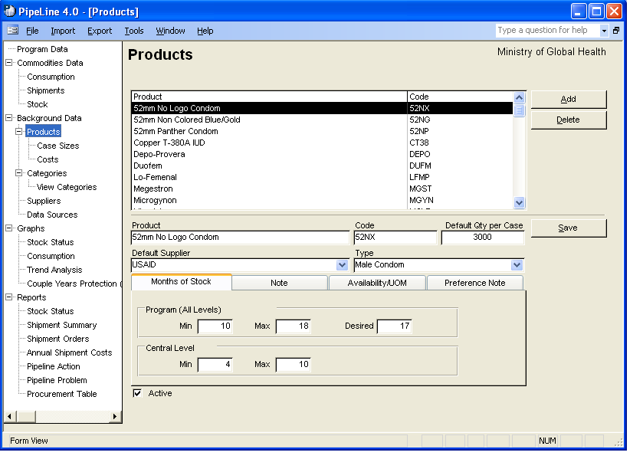
Figure 4-1—Products screen
The Products Tree View option enables you to modify product data; and change min/max stock levels, a default product supplier, or a product's category
or type.

- Click on the Products Tree
View option.

PipeLine opens the Products screen
(see Figure 4-1).

Adding a Product
Use the Add button to add a product. To add/update products from a file generated by an external procurement system see the PipeLine Utilities-Import Product Data section.

With the Products screen displayed—

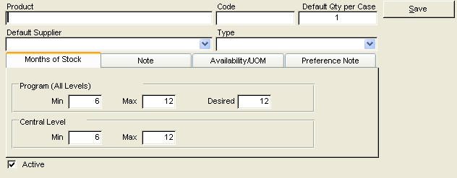
- Figure 4-2—Products screen data entry area Click on the Add button to display a blank Products screen (see Figure 4-2).

- Type the product name.

The Code field holds the product's code, which is used to help identify the product. Data in the Code field is created based on the name you give the product.

You may keep the PipeLine-generated code or use your own coding system.

To change the PipeLine-generated code—

- Highlight the PipeLine-generated code, and type the new code.
 | You are limited to 10 characters, which can be numbers, letters, spaces, or a combination of these.

The Default Qty per Case field shows the default product amount in a single case.

- Click on the Default Qty per Case field, and type the default product amount of a single case.

The Default Supplier field shows the product's default supplier.

- Click on the arrow next to the Default Supplier field, and select the product's default supplier from the pull-down menu.
 | If the supplier you need is not listed, you must add it. See Adding a Supplier on page 23.

Type refers to the group to which a product belongs (for example, contraceptives, HIV/AIDS test kits, etc.). It can also refer to a category of similar products (for example, sexually transmitted infection [STI] treatment drugs).

- Click on the arrow next to the Type field, and select the type (category) from the
pull-down menu.
 | If the type (category) you need is not listed, you must add it. See Adding a Category on page 18.

The Active field shows that the product is active. New products are active by default.

Months of Stock Tab
These fields enable you to set the product's minimum, maximum, and desired stock levels.

Program (all levels)
This area enables you to set stock levels for the entire program.

The Min field shows the minimum amount of stock (in months). The default is 6 (six months of stock). To change the default—

- Click on the Min field, and type the product's minimum stock level.

The Max field shows the maximum amount of stock (in months). The default is 12 (twelve months of stock). To change the default—

- Click on the Max field, and type the product's maximum stock level.

The Desired field shows the desired amount of stock (in months). The default is 12 (twelve months of stock). To change the default—

- Click on the Desired field, and type the product's desired stock level.

Central Level
This area enables you to set the stock level for your central facility.

The Min field shows the minimum amount of stock (in months). The default is 6 (six months of stock). To change the default—

- Click on the Min field, and type the product's minimum stock level.

The Max field shows the maximum amount of stock (in months). The default is 12 (twelve months of stock). To change the default—

- Click on the Max field, and type the product's maximum stock level.

The Note Tab
The Note Tab opens a memo field that enables you to enter additional information about the product.

- Click on the Note Tab, and enter any additional information about the product.

Availability/UOM Tab
These fields enable you to set the products availability, pack size, and basic unit of measure.
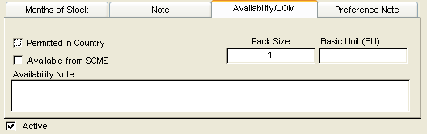
Figure 4-3—Products screen Availability/UOM tab

- Click on the Availability/UOM tab.

The Permitted in Country field shows whether the product is permitted in the county. The default is False. To change the default—

- Click on the Permitted in Country field.
 | If Permitted in Country is unchecked, then the product is either not permitted in the country or its permission is unknown.
The Available from SCMS field shows whether the product is available for procurement from SCMS. The default is False. To change the default—

- Click on the Available from SCMS field.

The Pack Size field shows the product’s quantity of basic units per pack. The default is 1 (one unit per pack). To change the default—

- Click on the Pack Size field, and type the product’s quantity of basic units per pack.

The Basic Unit (BU) field shows the product’s basic unit of measure.

- Click on the Basic Unit (BU) field, and type the product’s basic unit of measure.

The Availability Note is a memo field that holds information about the product’s availability.

- Click on the Availability Note field, and enter any information about the availability of the product.

Preference Note Tab
The Preference Note Tab opens a memo field that enables you to enter information about product preferences.

- Click on the Preference Note Tab, and enter any information about product preference.

When you finish—

- Click on the Save button to save the data, and return to the Products Selection form.

See Adding Case Size Data on page 13 for information about entering product case size data.

See Adding Cost Data on page 15 for information about entering product cost data.

Editing Product Data
 | If the product was imported from the SCMS product list, only a few fields can be edited.
Existing product data can be edited, as explained below.

With the Products screen displayed—

- Click on the product in the Product window that you want to edit.

Data associated with the selected product is displayed in the lower half of the Products screen.

- Click on the field you want to edit, and enter the new data.

- If the product is no longer active, click on the Active field.
 | A product should be marked inactive if you no longer monitor or procure it (i.e., a discontinued product).

- Click on the Note Tab, and enter the reason for the edit.

- Click on the Save button to save the data.

Deleting a Product
Use the Delete button to delete a product.

With the Products screen displayed—

- Select the product you want to delete.

- Click on the Delete button.

If the product can be deleted, PipeLine will display a confirmation message.

- Click on Yes to confirm the delete.

If you cannot delete the product (because it is associated with other records), PipeLine will display a message window.

- Click on OK to close the message window.

Case Sizes
 | Default Case Size, shown on the products screen, will be used if the case size is not entered for a specific supplier.
Case sizes are used to set a product's case size for a specific supplier. Shipment quantities are rounded up to the nearest case.

Adding Case Size Data
Use the Case Sizes option of the Tree View to access case size data.
!! | When adding Case Size records, you must first select the supplier and product from the pull-down menus.

- Click on the Case Sizes Tree View option.
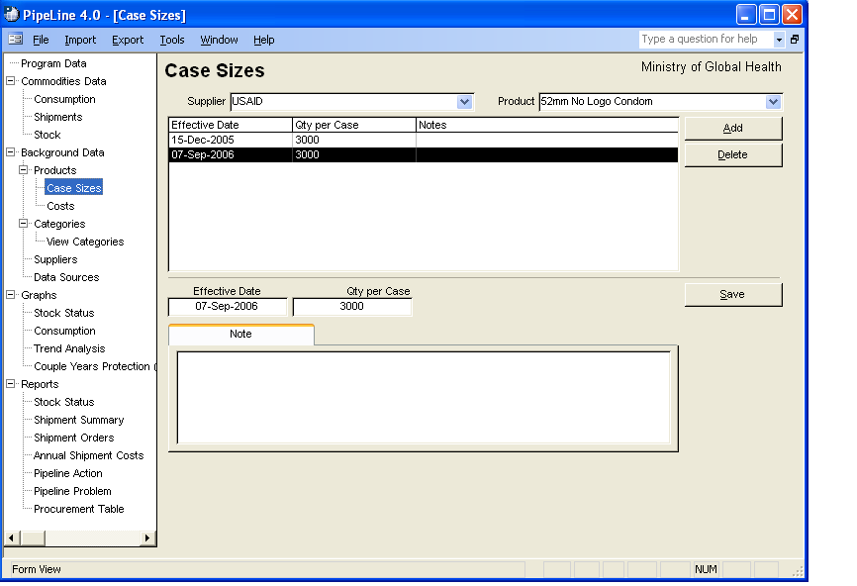
Figure 4-4—Case Sizes screen
The Product Case Sizes screen is displayed (see Figure 4-4).

- Click on the arrow next to the Supplier field, and select the supplier from the pull-down menu.

- Click on the arrow next to the Product field, and select the product from the pull-down menu.

- Click on the Add button.

The Effective Date field displays the date the case size becomes active. For a new product, the default Effective Date is the system date. Shipment amounts are calculated based on the active case size on the shipment's order date. The last case size entered remains active until a new case size with a later effective date is entered.

- Type the date the case size becomes effective.

The Qty per Case field shows the product amount in a single case from the selected supplier.

- Type the product amount of a single case.

The Note field is a memo field that holds additional information about the case size.

- Type any notes about the case size, if needed.

- Click on the Save button when you finish adding case size data.

Editing Case Size Data
Use the Case Sizes Tree View option to access case size data.

- Click on the Case Sizes Tree View option.

- Click on the arrow next to the Supplier field, and select the supplier from the pull-down menu.

- Click on the arrow next to the Product field, and select the product you want to edit from the pull-down menu.

- Select the case size data you need to edit.

- Click in the field you need to edit, and enter the new data.

- Click on the Save button to save your changes.

Deleting Case Size Data
Use the Case Sizes Tree View option to access case size data.

- Click on the arrow next to the Supplier field, and select the supplier from the pull-down menu.

- Click on the arrow next to the Product field, and from the pull-down menu, select the product with the case size data you want to delete.

- Click on the case size data you want to delete.

- Click on the Delete button.

A confirmation message is displayed.

- Click on Yes to delete the selected case size data.

Costs
Product costs are used to set a product's default cost.

Adding Cost Data
Use the Costs Tree View option to access the Costs screen.

- Click on the Costs Tree View option.
!! | When you add product cost data, first select the supplier and product from the pull-down menus.

PipeLine displays cost records for the selected supplier/product, if such data exists (see Figure 4-5).
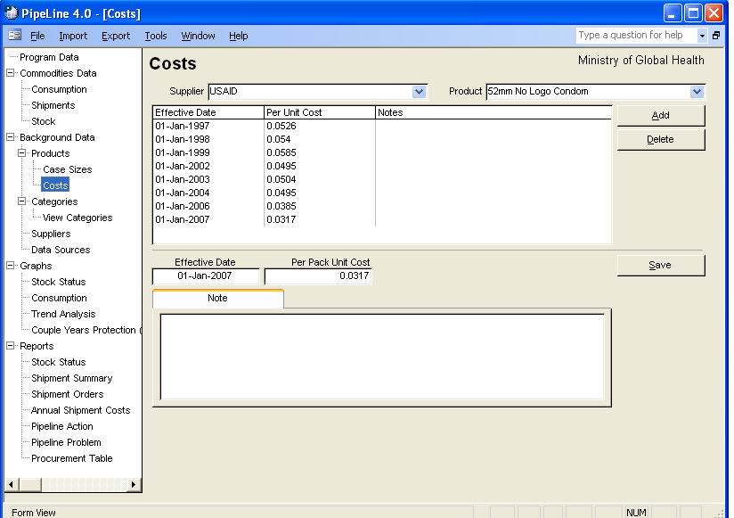
Figure 4-5—Costs screen
- Click on the arrow next to the Supplier field, and select the supplier from the pull-down menu.

- Click on the arrow next to the Product field, and select the product from the pull-down menu.

- Click on the Add button.

The Effective Date field shows the date on which the cost becomes active. Shipment costs are calculated based on the active cost on the ship date. The amount entered remains active until a new amount, with a later effective date, is entered.

- Type the date when the new cost becomes effective.

The Per Unit Cost field shows the product's unit cost. For the Cost reports to calculate complete costs, all products from each supplier must have cost data entered in this field and have an effective date prior to the shipment's ship date.

- Click in the Per Unit Cost field, and type the product's per unit cost.

The Note field is a memo field for additional information about the product's cost.

- Enter any relevant notes about the cost, if needed.

- Click on the Save button.

Editing Cost Data
Cost data can be edited, as explained below.

- Click on the Costs Tree View option.

- Click on the arrow next to the Supplier field, and select the supplier from the pull-down menu.

- Click on the arrow next to the Product field, and select a product from the pull-down menu.

Data associated with the selected product and supplier are displayed.

- Select the cost data you want to edit.

- Click in the field you need to edit, and enter the new data.

- Enter any relevant notes in the Note field about the changes made.

- Click on the Save button to save your changes.

Deleting Cost Data
Cost data can be deleted, as explained below.

- Click on the arrow next to the Supplier field, and select the supplier from the pull-down menu.

- Select the product with the cost data you need to delete.

Data associated with the selected product and supplier is displayed.

- Select the cost record you need to delete, and click on the Delete button.

A confirmation message is displayed.

- Click on Yes to delete the selected record.

Categories
Category refers to a group of related products (i.e., contraceptives, HIV/AIDS test kits, malaria drugs, etc.). It can also be used to categorize similar products (e.g., sexually transmitted infection treatment drugs). Use the Categories Tree View option to access Category data.

- Click on the Categories Tree View option.
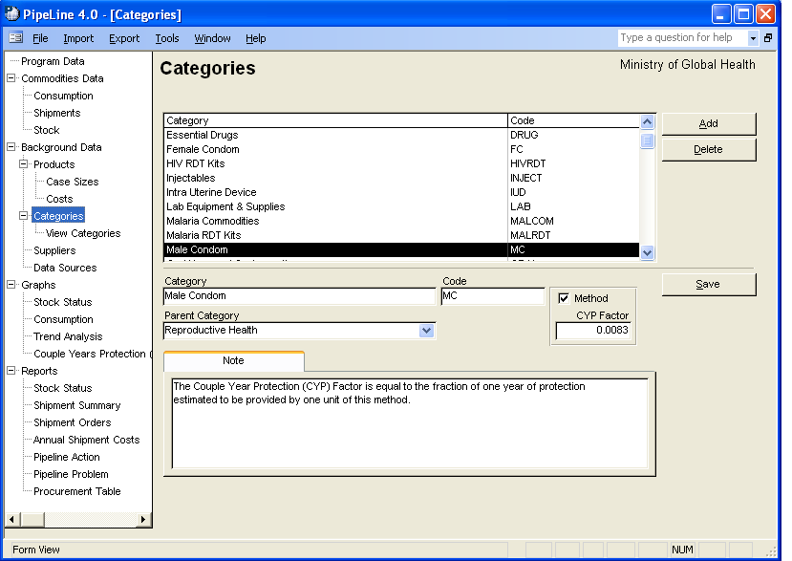
Figure 4-6—Categories screen
The Categories screen is displayed. See Figure 4-6.

Adding a Category
Use the Add button to add a new category.

With the Categories screen displayed—

- Click on the Add button.
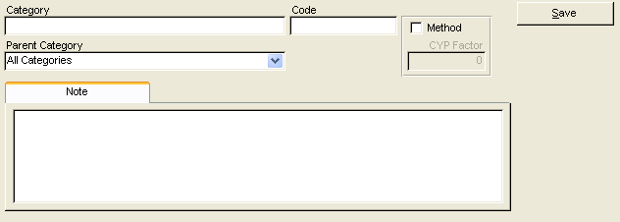
Figure 4-7—Categories screen data entry area

PipeLine blanks out the data entry area of the Categories screen as shown in Figure 4-7.

- Type the category name.

The Code field holds the category's code, which is used to help identify the category. Data in the Code field is created based on the name you give the category.

You may keep the PipeLine-generated code or use your own coding system.

To change the PipeLine-generated code—

- Highlight the PipeLine-generated code, and type the new code.
 | You are limited to 10 characters, which can be numbers, letters, spaces, or a combination of these.

The Parent Category field identifies the primary group to which the new category belongs.

- Click on the arrow next to the Parent Category field, and select an appropriate category from the pull-down menu.

The Method field allows you to associate the new category with a CYP Factor.

A CYP factor is the couple-years of protection. The CYP factor is the fraction of a year of protection provided by one unit of a particular contraceptive product. The CYP factor field can only be used if the category you are creating has been designated a Method.

- Click on the Method field if you want to designate the category as a method.

- Type the CYP factor.

The Note field is a memo field for additional information about the new category.

- Type any relevant notes in the Note field.

When you finish adding category data—

- Click on the Save button to save the data.

Editing Category Data
Use the Categories Tree View option to edit the category data.

With the Categories screen displayed—

- Select the category you want to edit.

- Click in the field you want to edit, and enter the new data.

When you finish editing—

- Enter any relevant notes in the Note field about the changes made.

- Click on the Save button to save the changes.

Deleting a Category
Use the Delete button to delete a category.

With the Categories screen displayed—

- Click on the category you want to delete.

- Click on the Delete button.

If the category can be deleted, PipeLine will display a confirmation message.

- Click on Yes to confirm the delete.

If you cannot delete the category (because it is associated with other database records), PipeLine will display a message window.

- Click on OK to close the message window.

Viewing Category Relationships
The View Categories option of the Tree View enables you to view all existing categories and their relationships (if any).

- Click on the View Categories option of the Tree View.

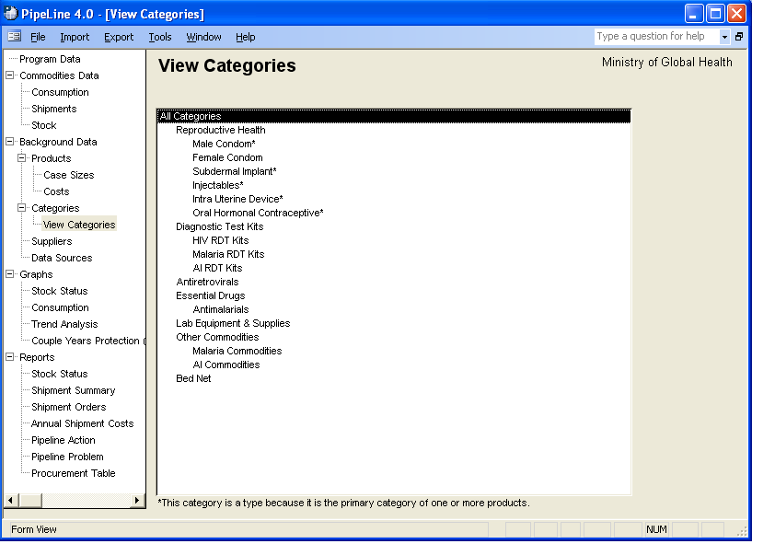
Figure 4-8—View Categories screen All existing categories and types are listed. See Figure 4-8.

Suppliers
 | Categories designated as types in product records are displayed with an asterisk (*).
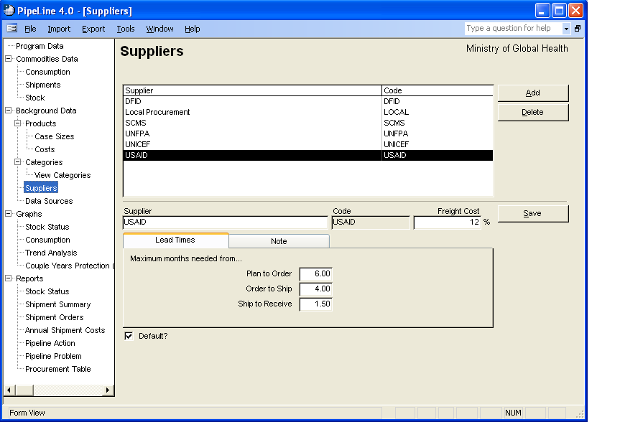Figure 4-9—Suppliers screen
Use the Suppliers option
of the Tree View to
modify the Supplier pull-down menu, change shipment lead times by supplier, and to estimate shipping costs by supplier.

- Click on the Suppliers Tree
View option.

Pipeline displays the Suppliers screen. See Figure 4-9.

Adding a Supplier
Use the Add button to add a supplier.

With the Supplier screen displayed—

- Click on the Add button.

PipeLine blanks out the lower half of the Suppliers screen (see Figure 4-10).
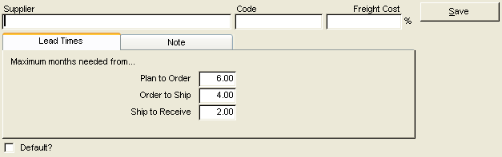
Figure 4-10—Suppliers screen data entry area

- Click in the Supplier field, and type the supplier's name.

The Code field holds the supplier's code, which identifies the supplier. Data in the Code field is created based on the name you give the supplier.

You may keep the PipeLine-generated code or use your own coding system.

To change the PipeLine-generated code—

- Highlight the PipeLine-generated code, and type the new code.
 | You are limited to 10 characters, which can be numbers, letters, spaces, or a combination of these.

The Freight Cost field shows the approximate freight cost for a shipment as a percentage of the shipment's value. If you do not fill in this field, PipeLine uses the program's default freight cost.

- Click in the Freight Cost field, and type the freight cost percentage.

The Default field shows that the supplier is the default supplier for your program. PipeLine chooses the default for a product when no supplier is specified.

- Click in the Default field if the new supplier will be your default supplier.

Lead Times Tab
The Plan to Order field shows the estimated lead time (in months) expected from the time a shipment is planned to when it is ordered. The default is 6.00 (six-month lead time). To change the default—

- Click on the Plan to Order field, and type the plan to order lead time.

The Order to Ship field shows the estimated lead time (in months) expected from the time a shipment is ordered to when it is shipped. The default is 4.00 (four-month lead time). To change the default—

- Click on the Order to Ship field, and type the order to ship lead time.

The Ship to Receive field shows the estimated number of months expected from the time a shipment is shipped until it is received. The default is 2.00 (two-month lead time). To change the default—

- Click on the Ship to Receive field, and type the ship to receive lead time.

The Note Tab
Use the Note Tab to add a memo about the supplier.

- Click on the Note tab, and type any relevant note about the new supplier.

- Click on the Save button to save your data.

Editing Supplier Data
With the Suppliers screen displayed—

- Select the supplier you want to edit.

- Click in the field you want to edit, and enter the new data.

- Click on the Note tab, and type the reason for the edit.

- Click on the Save button to save your changes.

Deleting a Supplier
Use the Delete button to delete a supplier.

With the Suppliers screen displayed—

- Select the supplier you want to delete, and click on the Delete button.

If the supplier can be deleted, PipeLine will display a confirmation message.

- Click on Yes to confirm the delete.

If you cannot delete the supplier (because it is associated with other database records), PipeLine will display a message window.

- Click on OK to close the message window.

Data Sources
The Data Sources option of the Tree View enables you to indicate sources from which pipeline data is gathered. Data Source records are grouped as follows:

- Actual Consumption—sources for actual consumption records
- Forecast Consumption—sources for forecast consumption records
- Stock—sources for stock records, including stock count and adjustment
- Shipments—sources for shipment records.

- Click on the Data Sources Tree View option to access the Data Sources screen.

PipeLine displays the Data Sources screen (see Figure 4-11).
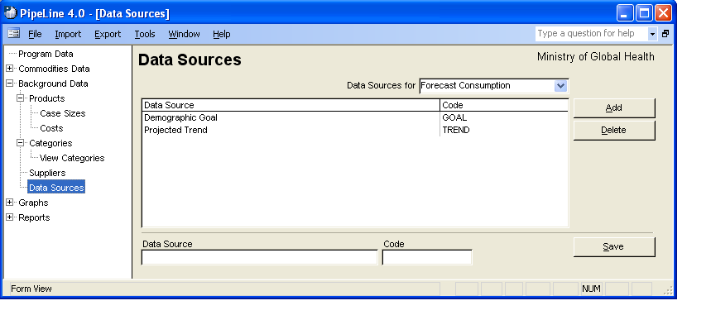Figure 4-11—Data Sources screen

Adding a Data Source Option
Use the Add button to add a new data source option.

- Click on the arrow next to the Data Sources For field, and from the pull-down menu, select the data source group where you want to add a new option.

- Click on the Add button.

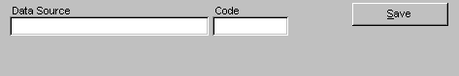
Figure 4-12—Data Sources screen data entry area PipeLine blanks out the lower half of the Data Sources screen (see Figure 4-12).

- Type the source name.

The Code field holds the code for the data source's code, which identifies the data source option. Data in the Code field is created based on the name you give the data source option.

You may keep the PipeLine-generated code, or use your own coding system.

To change the PipeLine-generated code—

- Highlight the PipeLine-generated code, and type the new code.
 | You are limited to 10 characters, which can be numbers, letters, spaces, or a combination of these.
- Click on the Save button to save the data.

Editing Data Source Options
You can edit Data Sources information as described below.

With the Data Sources screen displayed—

- Click on the arrow next to the Data Sources For field, and select the data source group from the pull-down menu.

- Click on the data source option you need to edit.

- Click in the field you need to edit, and type the new data.

- Click on the Save button to save the changes.

Deleting a Data Source Option
Use the Delete button to delete a data source option.

With the Data Sources screen displayed—

- Click on the arrow next to the Data Sources field, and from the pull-down menu, select the data source group with the information you want to delete.

- Click on the data source option you need to delete.

- Click on the Delete button.

If the data source option can be deleted, PipeLine will display a confirmation.

- Click on Yes to confirm the delete.

If you cannot delete the data source option (because it is associated with other database records), PipeLine will display a message window.

- Click on OK to close the message window.

